Assignment 2

1. Add a 10GB disk to the CentOS.

Add 10 GB disk to the centOS

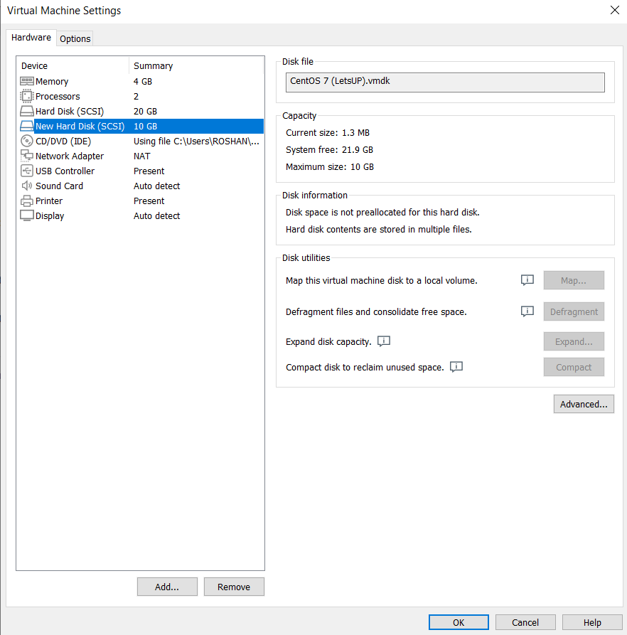

Create 2 Partition 4GB and 6GB of Space respectively.

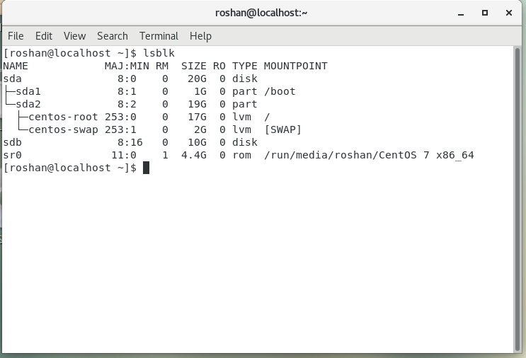

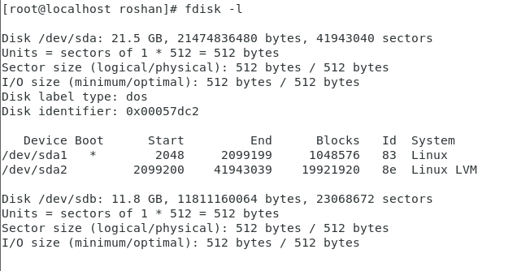

2. Create 2 Partitions 4GB and 6GB of Space respectively.

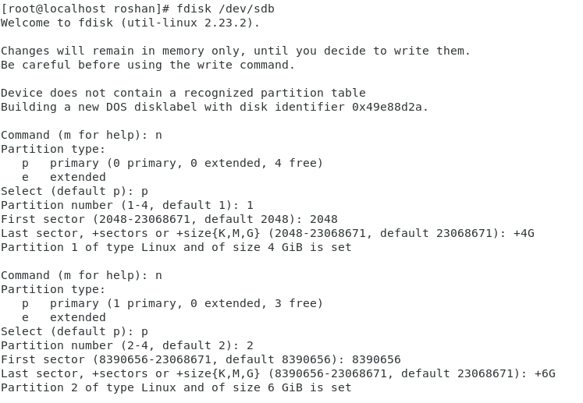

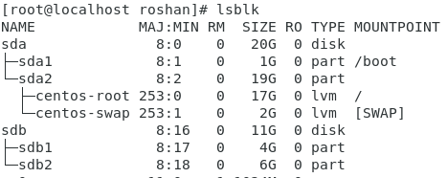

3. Format 4GB with xfs and 6GB with ext4 file system.

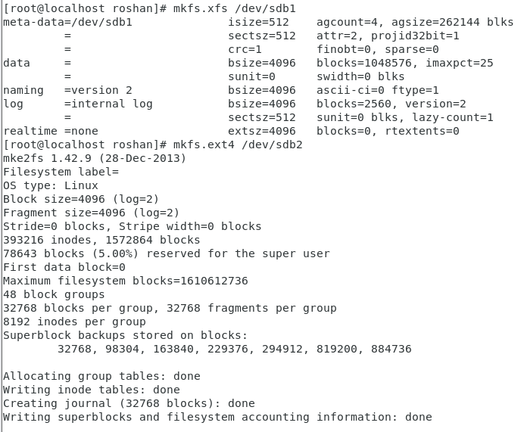

4. Mount 4GB and 6GB in /data and /music directory respectively.



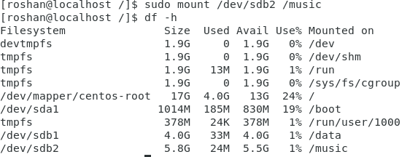

5. Create one file of 1GB in each of the mount point created above.

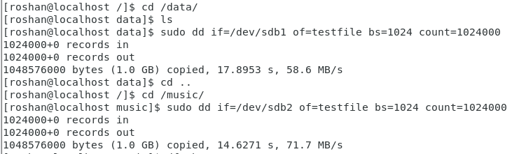 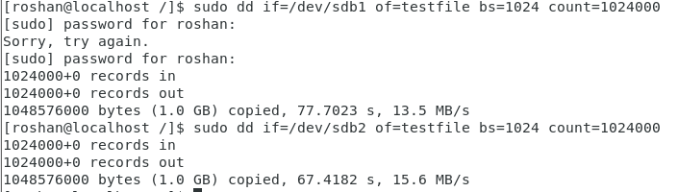

6. Verify the disk Consumption and disk space free in the mounted partitions.

